ResNet 50 + BiLSTM

Try 1:

optimizer=**RMSprop**(learning_rate=2e-5)

batch_size = 2

epochs = 4

bilstm_model.add(**Dropout**(0.3))

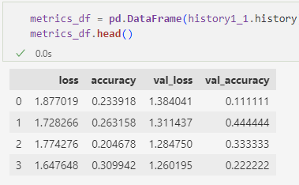

Try 2:

optimizer=**Adam**(learning_rate=0.0001)

*# Define a learning rate schedule function*

from **keras**.**callbacks** import **LearningRateScheduler**

def **lr_schedule**(epoch, current_lr):

    if epoch < 3:

        return current_lr  *# Keep the initial learning rate for the first 5 epochs*

    else:

*# Increase the learning rate by 3 times after the 5th epoch*

        return current_lr * 0.1

*# Create a learning rate scheduler*

lr_scheduler = **LearningRateScheduler**(**lr_schedule**)

bilstm_model.add(**Dropout**(0.5))

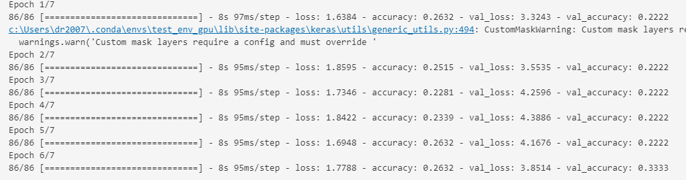

Try 3:

optimizer='adam'

no learning scheduler

bilstm_model.add(**Dropout**(0.5))

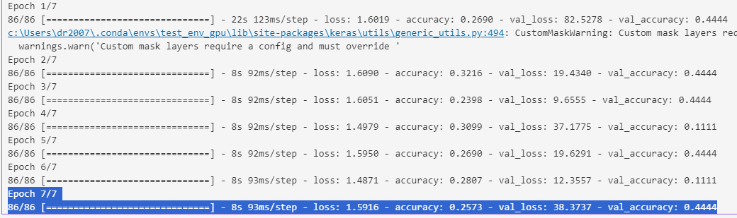

ResNet 50 (Alone)

Try 1:

Try 2:

